**PRACTICAL: 7**

**AIM:**

Kubernetes in Google Cloud: Kubernetes is the most popular container orchestration system and the Google Kubernetes Engine was designed specifically to support managed Kubernetes deployments in the Google Cloud. In this advanced-level quest, you will get hands-on practice configuring Docker images and containers, and deploying fully-fledged Kubernetes Engine applications. This quest lab will teach you the practical skills needed for integrating container orchestration into your own workflow.

**THEORY: // (RELATED TO PRACTICAL)**

// Times New Roman 12

**CODE:**

|  |
| --- |
| Code //  Times New Roman 12 |

**OUTPUT: // (SCREENSHOT/S WITH EXPLANATION)**



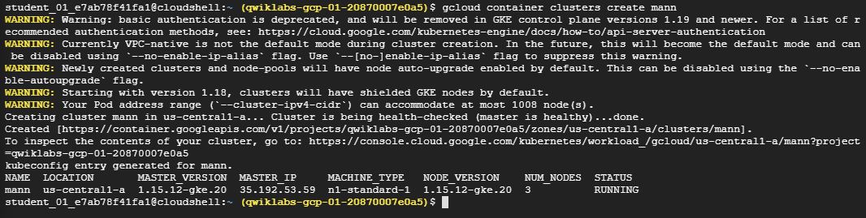







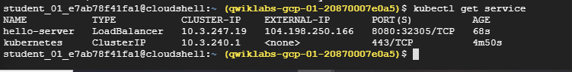

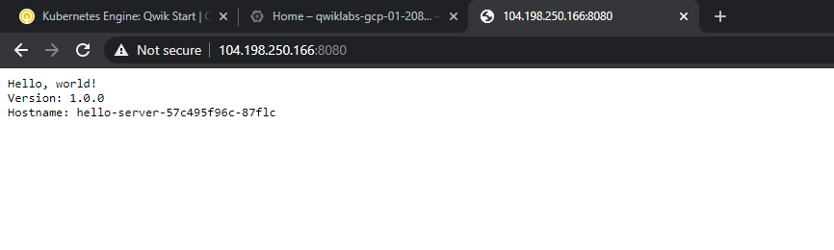

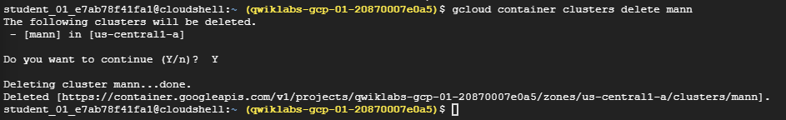

**LATEST APPLICATIONS: // (OF THIS PRACTICAL/TOOL IN REAL LIFE)**

// Times New Roman 12

**LEARNING OUTCOME:**

// Times New Roman 12

**REFERENCE:**

1. <https://google.qwiklabs.com/quests/29>